Quiz 2

Name: Jacob Wall

1. ABC Corporation is a US entity that lent money to a French corporation. During 2013, ABC received interest payments of $5 million, which were subject to a 10% French withholding tax (paid by the borrower directly to the French government). Assume ABC has no other income or expenses and is subject to a 35% US tax rate on all of its income. How much US tax would ABC owe for the year?

$1,575,000

2. Alex owns a piece of land with a mortgage (and a fair value) of $1,050,000. A buyer offers to purchase the land for no cash but will assume all of Alex’s debt. Alex’s basis in the property is $1,750,000. What is Alex’s gain or loss on the sale?

|  |  |
| --- | --- |
| Proceeds, debt assumption: | $1,050,000 |
| Adjusted Basis: | $1,750,000 |
| Gain / (Loss) | ($700,000) |

Loss of $700,000.

3. Pat owns some land with a fair market value of $800,000 and an adjusted basis of $325,000. He also owes the bank $450,000 on the mortgage. Jeff owns some land with a fair market value of $400,000 and an adjusted basis of $275,000. There is no debt of Jeff’s land. Pat and Jeff agree to exchange properties (subject to the existing mortgage on Pat’s land). Pat will also pay Jeff $50,000 in cash. What is the realized gain, recognized gain and basis in the new properties for both Pat and Jeff?

|  |  |  |  |  |
| --- | --- | --- | --- | --- |
| Pat | |  | Jeff | |
| Realized | $575,000 |  | Realized | $75,000 |
| Recognized | $450,000 |  | Recognized | $50,000 |
| Basis | $275,000 |  | Basis | $775,000 |

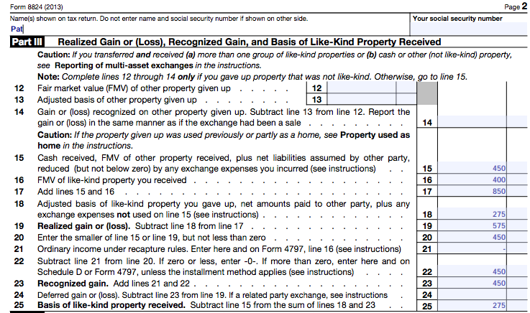

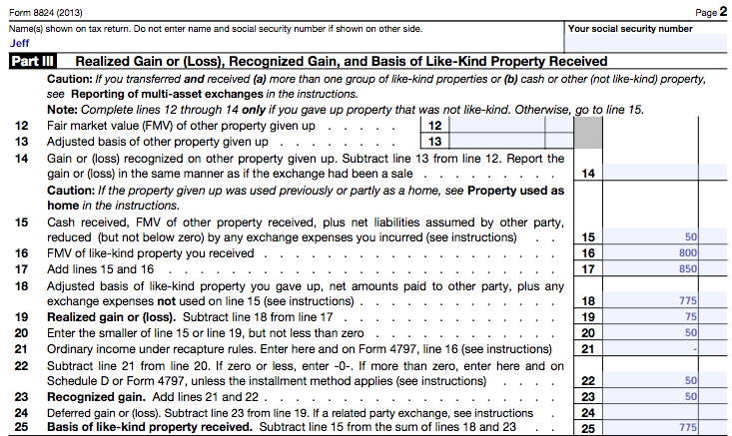

4. Baker purchased a call option to acquire 1,000 shares of XYZ stock at a strike price of $21 per share. The option premium was $1,000.

(a) At what share price will the option be “in the money.” $22.

(b) Assume Baker exercises his option. How is the premium accounted for from both Baker’s and the option seller’s perspective?

Baker – Added to his basis by the option premium amount.

Seller – Reduces his basis by the option premium amount.

(c) Assume Baker let the option lapse. How is the premium accounted for from both Baker’s and the option seller’s perspective?

Baker – Capital loss of $1,000

Seller – Realized and recognized gain of $1,000.

5. Charles sold 1000 shares of ABC stock short at $12 per share. Later, when the market price of ABC stock was $9 per share, he closed the position. What was Charles gain or loss?

$3,000 Capital Gain.